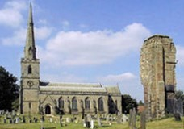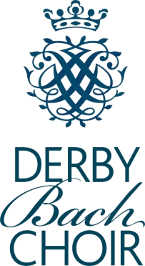
Why not join us?
If you would like to join us in singing Fauré’s Requiem and Cantique de Jean Racine, plus other sacred works from the European Sacred Music OUP collection please fill in the booking form overleaf.
Please invite friends, colleagues and family to join us in the audience (at a cost of £5 per adult payable at the door) at 6.00pm.
Supper for audience may be
available by prior arrangement.
Forthcoming events
There is more information on forthcoming Derby Bach Choir events on our website at:
www.derbybachchoir.com
Our Summer Concert: ‘An Italian Evening’ on Saturday 20th June, 7.30pm at St. John the Evangelist Church, Mill Street, Derby DE1 3HZ.
Come and listen to works by Monteverd, and Vivaldi
Tickets for all events can be bought from our website or from any of our choir members & on the door.

We look forward to seeing you!
Directions and map

St. George’s Church is at the end of Church Lane, off the A514 Burton Road in Ticknall village.

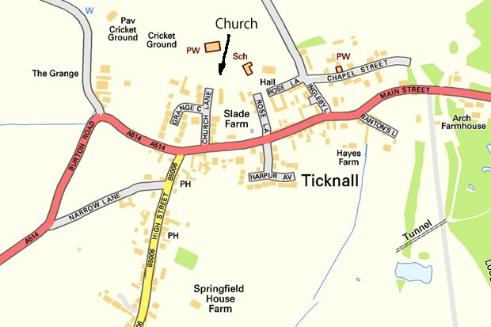

Please park in the Village Hall car park off Ingelby Lane, or at the Car Park at the end of Rose Lane.

www.derbybachchoir.com

Invites you to
Come and Sing
Fauré Requiem

Cantique de Jean Racine
Panis Angelicus by Franck
Saturday 9th May 2026
1.30pm
at
St. George’s Church
Ticknall, DE73 7JU
Conductor: James Foulds Organist: Tom Corfield

Programme for the Day
1.30 pm
Registration
1.45 pm
Rehearsal
3.00 pm
Tea Break
3.30 pm
Rehearsal
6.00 pm
Performance
7.00 pm
Bar open in hall,
followed by supper
The cost for the day will be £28 which includes buffet supper.

Please indicate if you have special dietary needs
Please note that the timings for breaks are approximate

If you wish to participate, please complete the booking form on the next page.
A link to Learning aid scan be found on the ‘Come and Sing’ page on our website: www.derbybachchoir.com.

All are welcome to this event, from newcomers to experienced singers. We offer a day of learning, good value, good fun and the joy of all singing together.
One participant told me Derby Bach Choir’s Come & Sing was his favourite – at the time he was loading his plate with a delicious supper! But he did add that it was the friendly welcome, as well as James’s excellent mixture of encouragement and good- humoured expectation of a quality performance.

James Foulds Derby Bach Choir’s associate conductor is at the centre of Derby’s music community. He has a lifetime’s experience of choral music, both as a conductor and as a singer.

Tom Corfield is one of the area’s most outstanding and widely respected organists and accompa- nists. He is Derby Bach Choir’s regular accompanist.

Please complete and return by 6th May to
help us plan the catering.

Name ..............................................................

Address ...........................................................

........................................................................
........................................................................

Telephone ........................................................

Email ................................................................

Voice part (please tick):

Soprano □ Tenor □

Alto □ Bass □

You can hire music at £1 per copy payable on the day. Please indicate below if you want to do this.

□ I require a copy of Faure Requiem (Ricordi)
□ I require a copy of European Sacred Music (OUP)
which contains the Cantique & Panis Angelicus

Please enclose a cheque payable to
‘Derby Bach Choir’ for £28 or pay online at
www.derbybachchoir.com
Jenny Casboult, ‘Springfield House’, Church Lane, Thorpe, Ashbourne, Derbyshire, DE6 2AW.
Telephone: 01335 350285 Email: gcasboult@yahoo.com

